**Experiment: Deploying a Node.js Web Application on AWS**

HARDWARE REQUIREMENTS: Core I5 Processor, 4 GB RAM, 40GB HDD

SOFTWARE REQUIREMENTS: Amazon AWS, EC2, VS Code/Eclipse, Node, NPM, GIT,

Putty

**Description:**

Node.js is a JavaScript runtime environment that allows one to run JS on the server. It is built on the open-source V8 JavaScript engine used in Chrome and written in C++ which executes JS in a standalone environment.

In this experiment, we clone a Nodejs application from GITHUB and deploy this application on to Amazon EC2 instance, make it available over Amazon AWS URI.

**Steps to configure EC2 Instance :**

**1. Create an EC2 instance and Launch it:**

Choose amazon Ec2 instance machine image as Ubuntu 18.04 64 bit with type of micro.

(Login to AwsAcademy,

LMS-Dashboard - AWS Academy Learner Lab – Educator

Click on Modules

Click on Learner Lab

Click on Start Lab

Click on AWS

Services – EC2

EC2 – Instances – Launch an instance

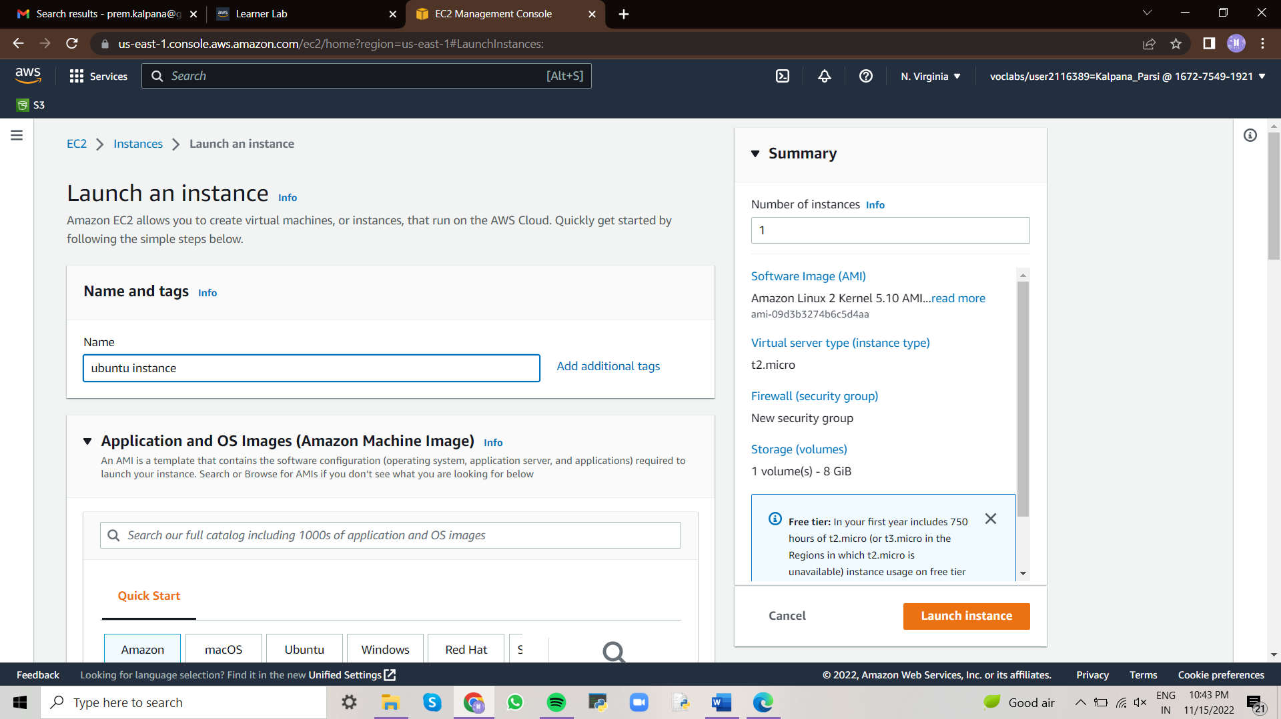

Select Amazon Ubuntu

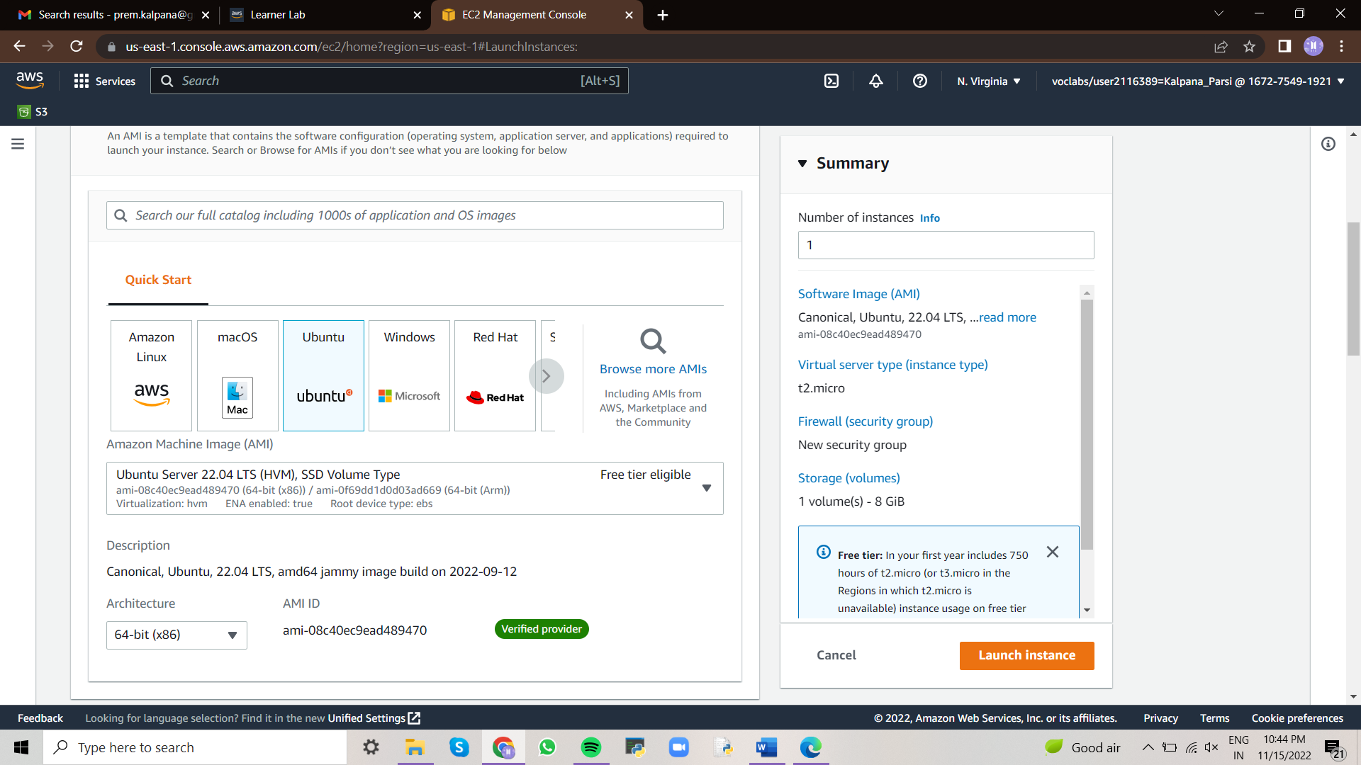

Instance type - t2.micro)

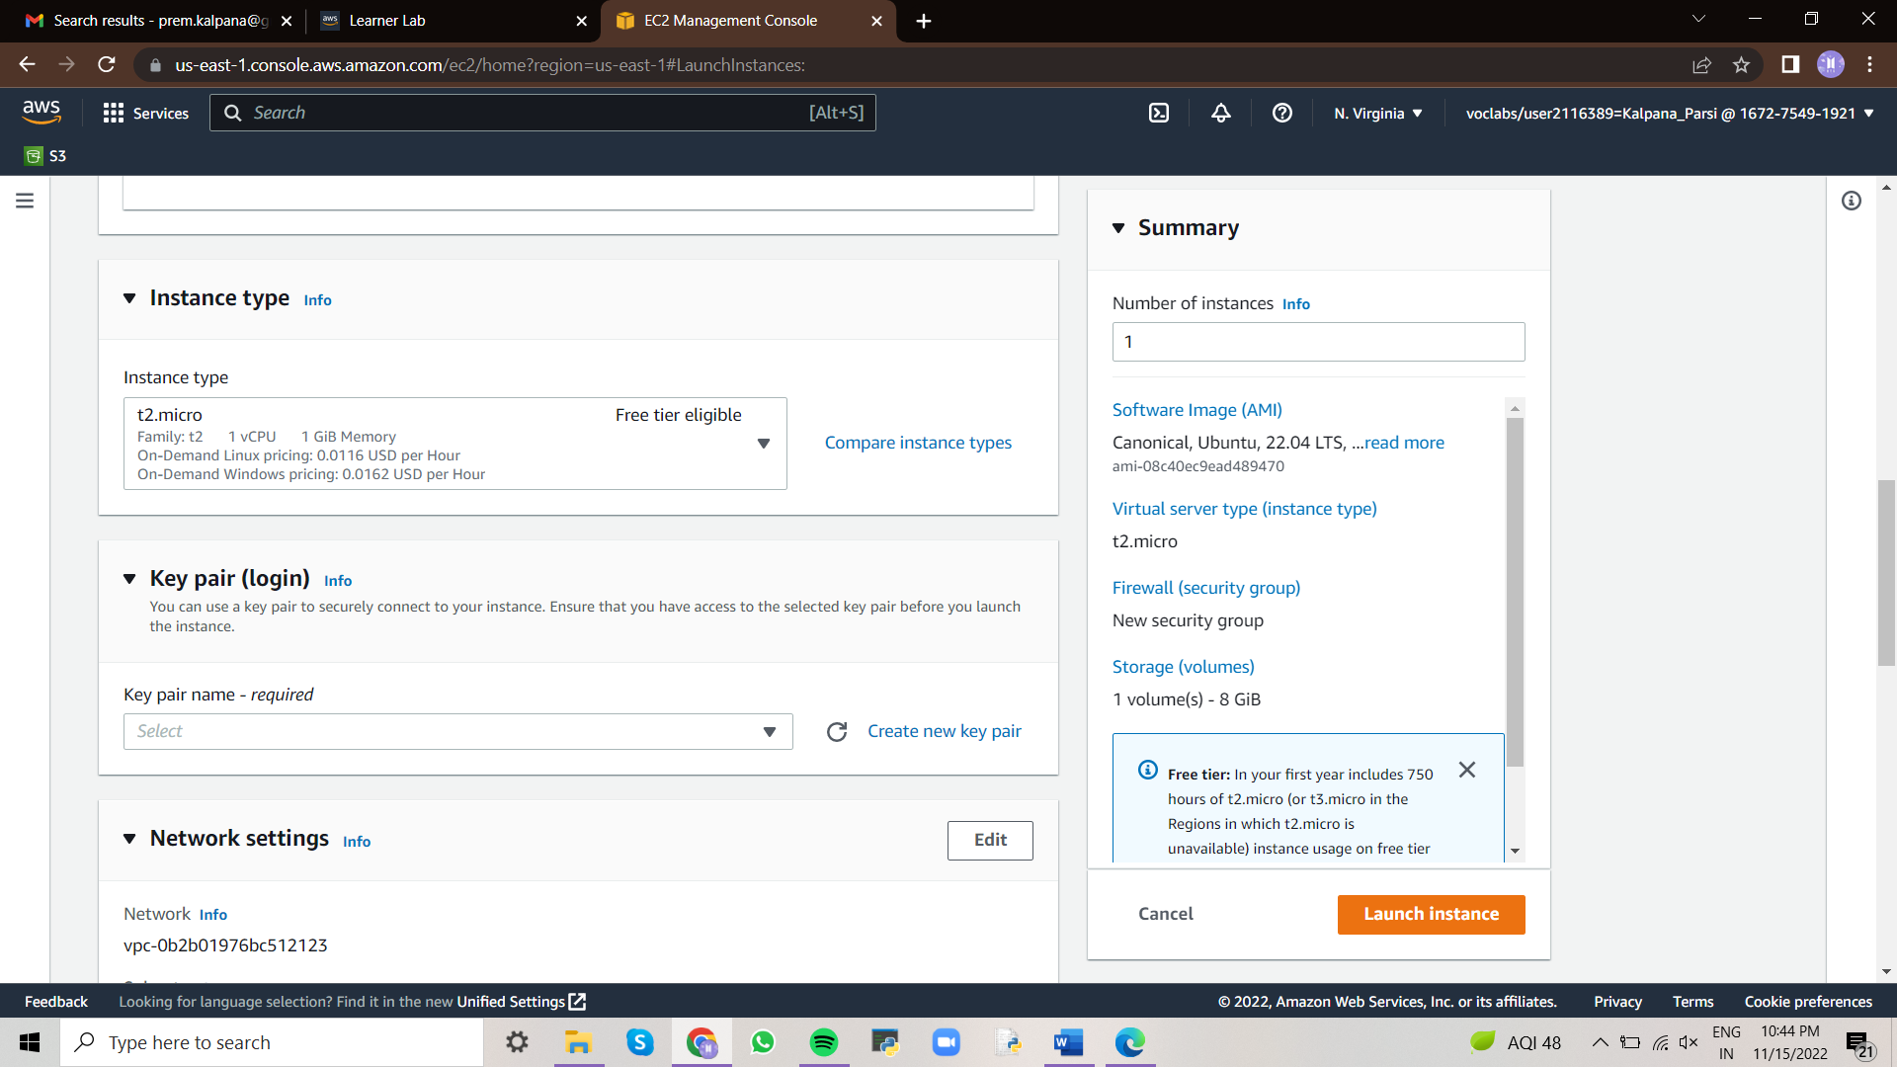

Create new key pair – Save the key pair as .ppk (to work with putty)

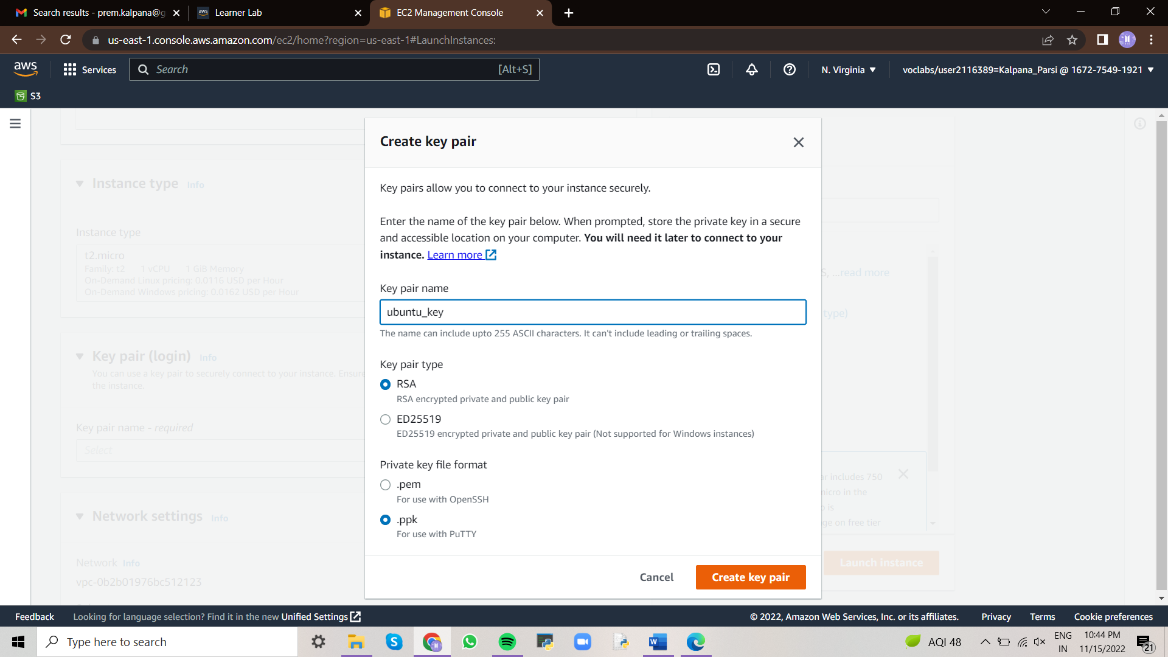

Next Add storage

Next configure Security Group – Create security group.

In this step we need to allow http and https requests to access from any group.

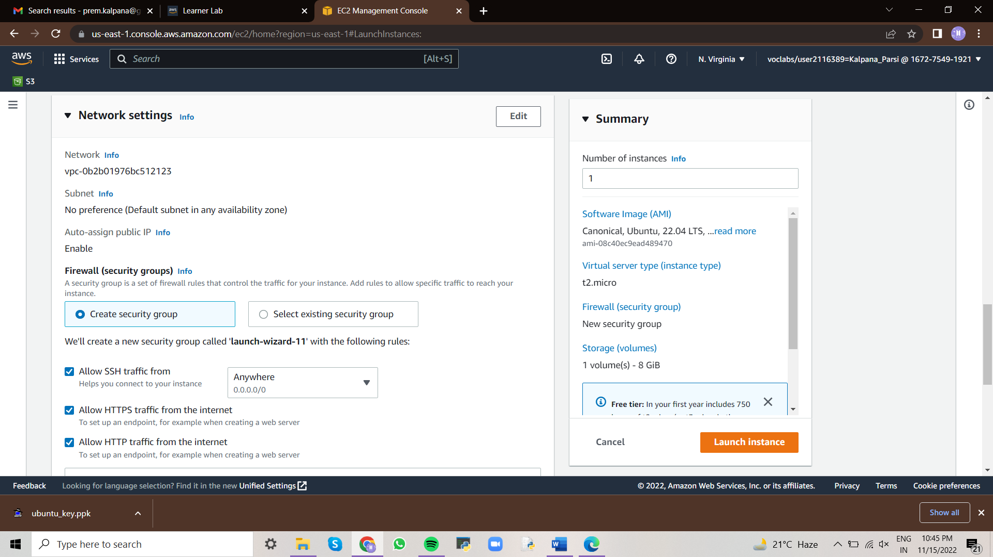

Finally click on Launch instance.

We can see instance is launched successfully.

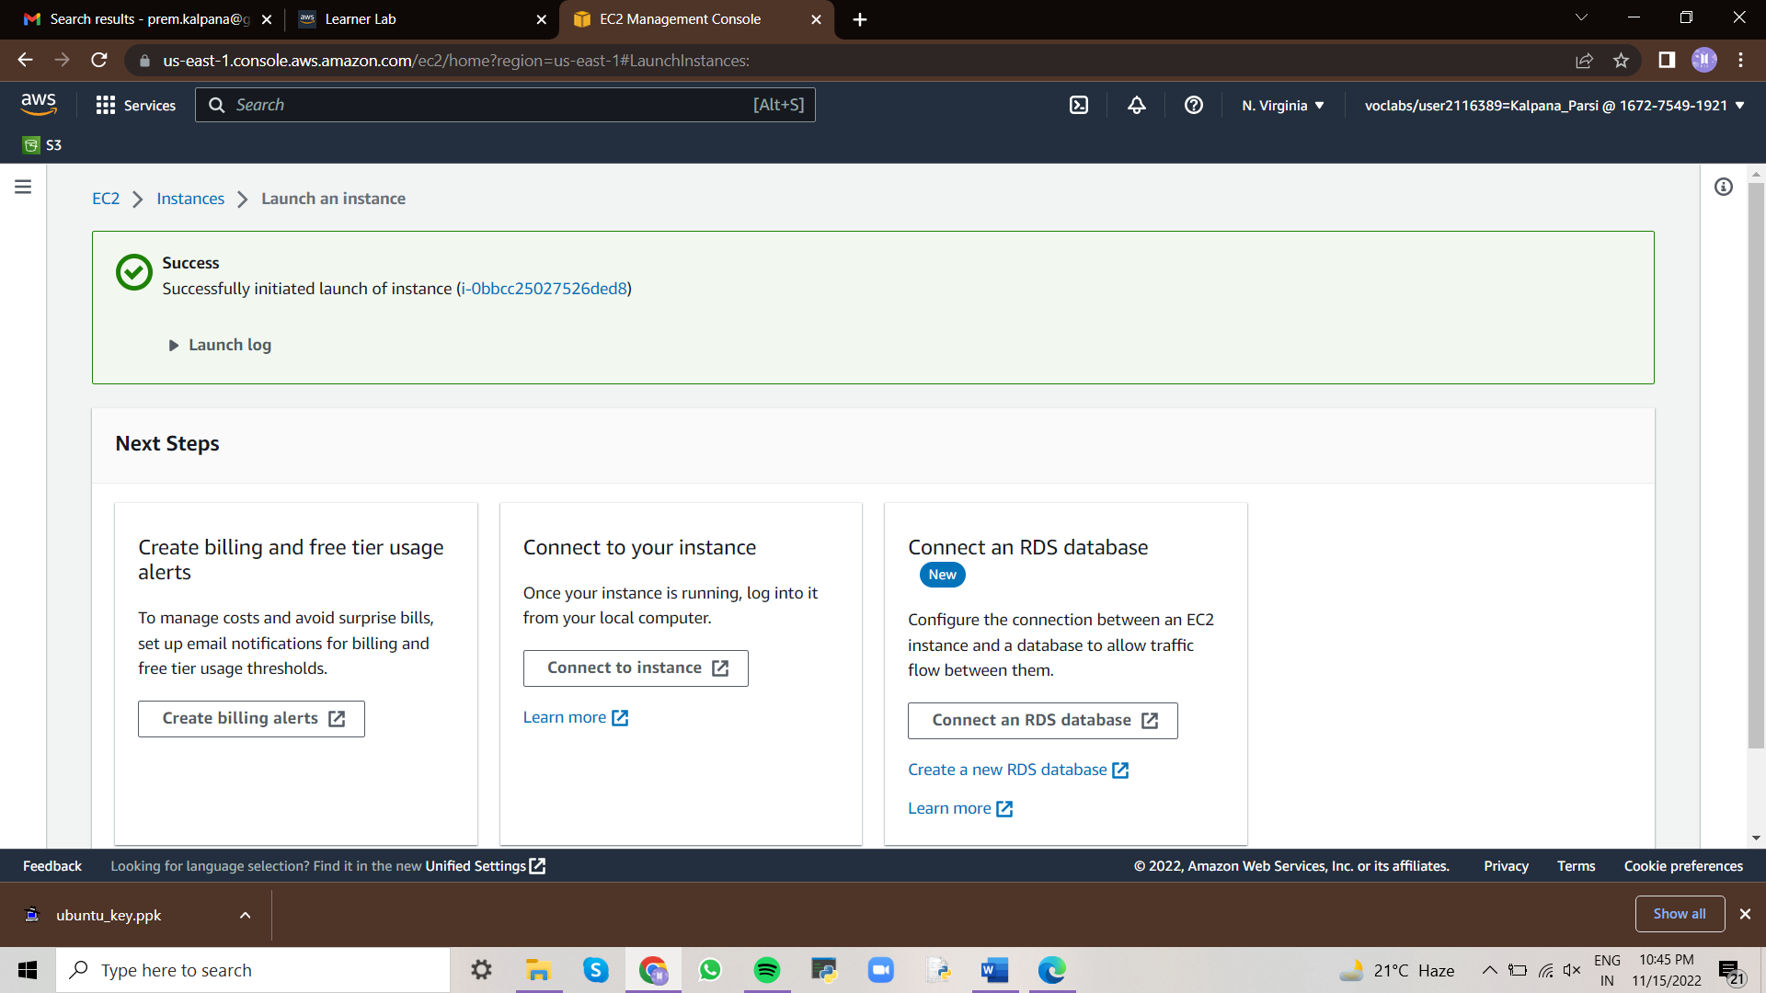

When the instance state is running , it indicates that your instance was created successfully.

Copy the public DNS of your Instance. You can access different app running on your instance at a different port.

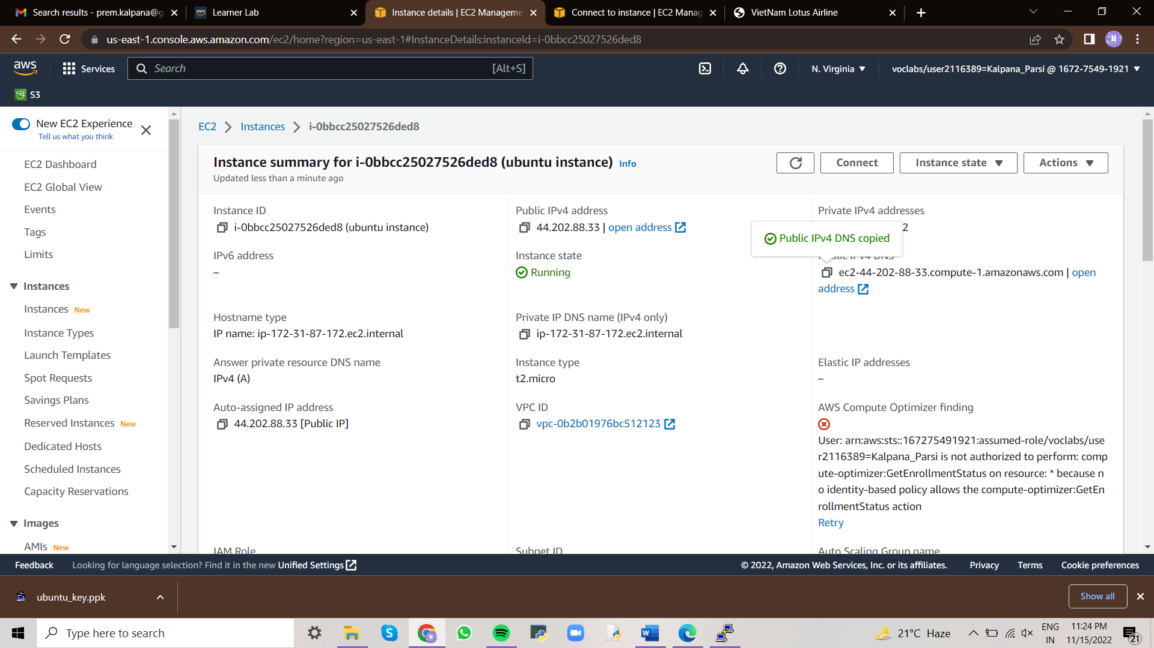

**2. Connect to your Instance:**

Click on launch instance then it shows popup window giving details how to connect to your instance.

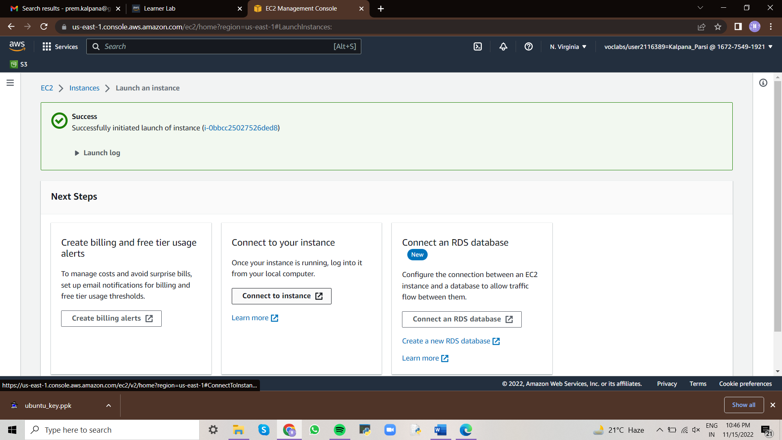

To open SSH client and lf we are in windows platform we need to launch the instance with the help of putty soft.

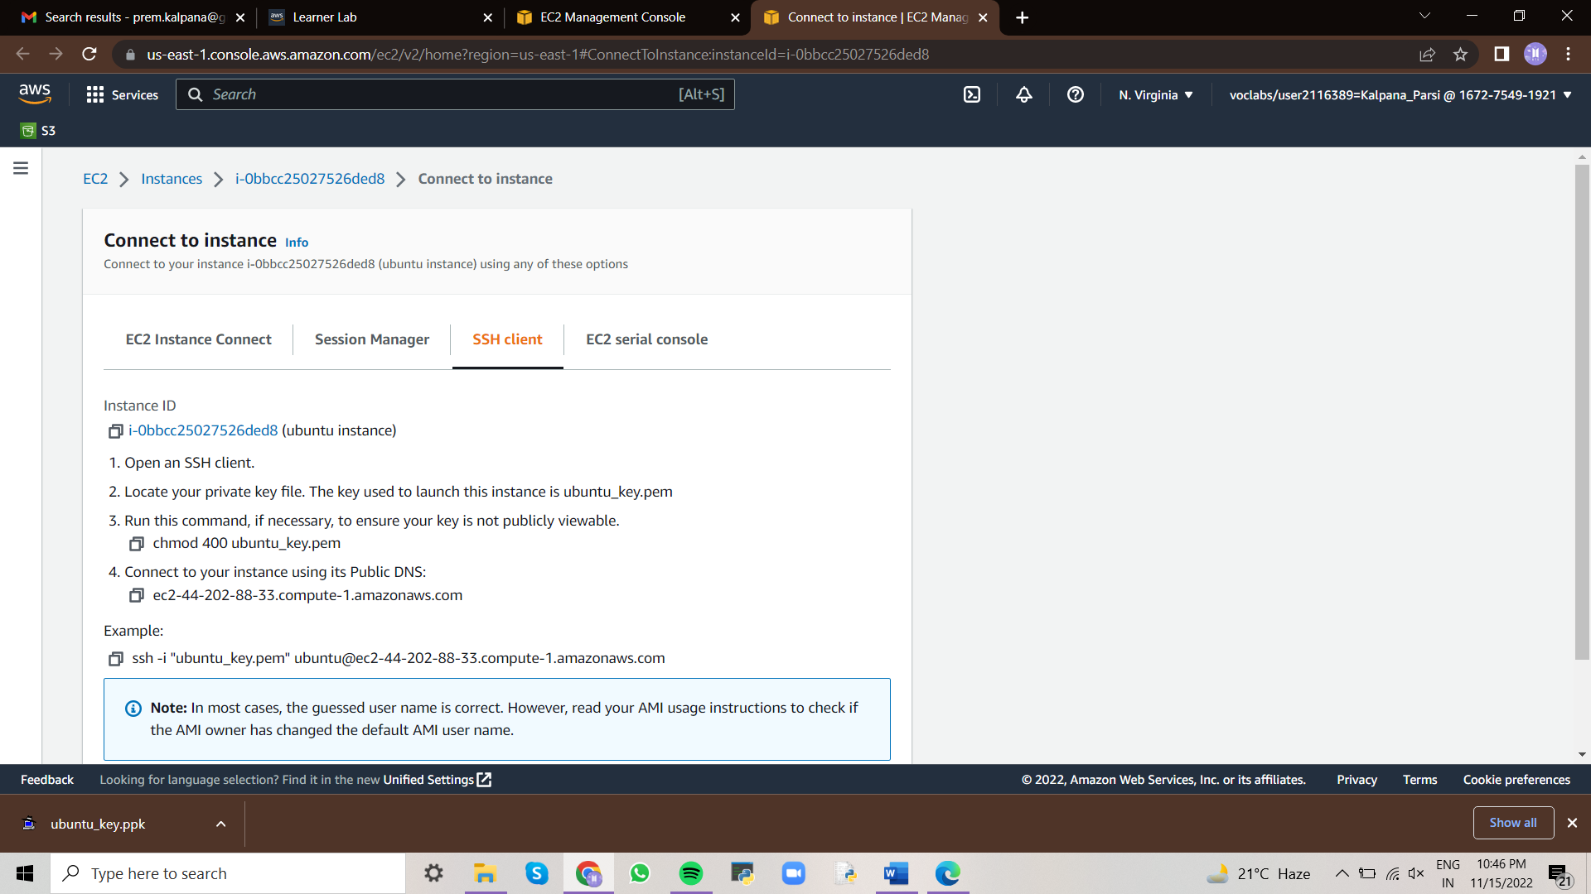

Open Putty

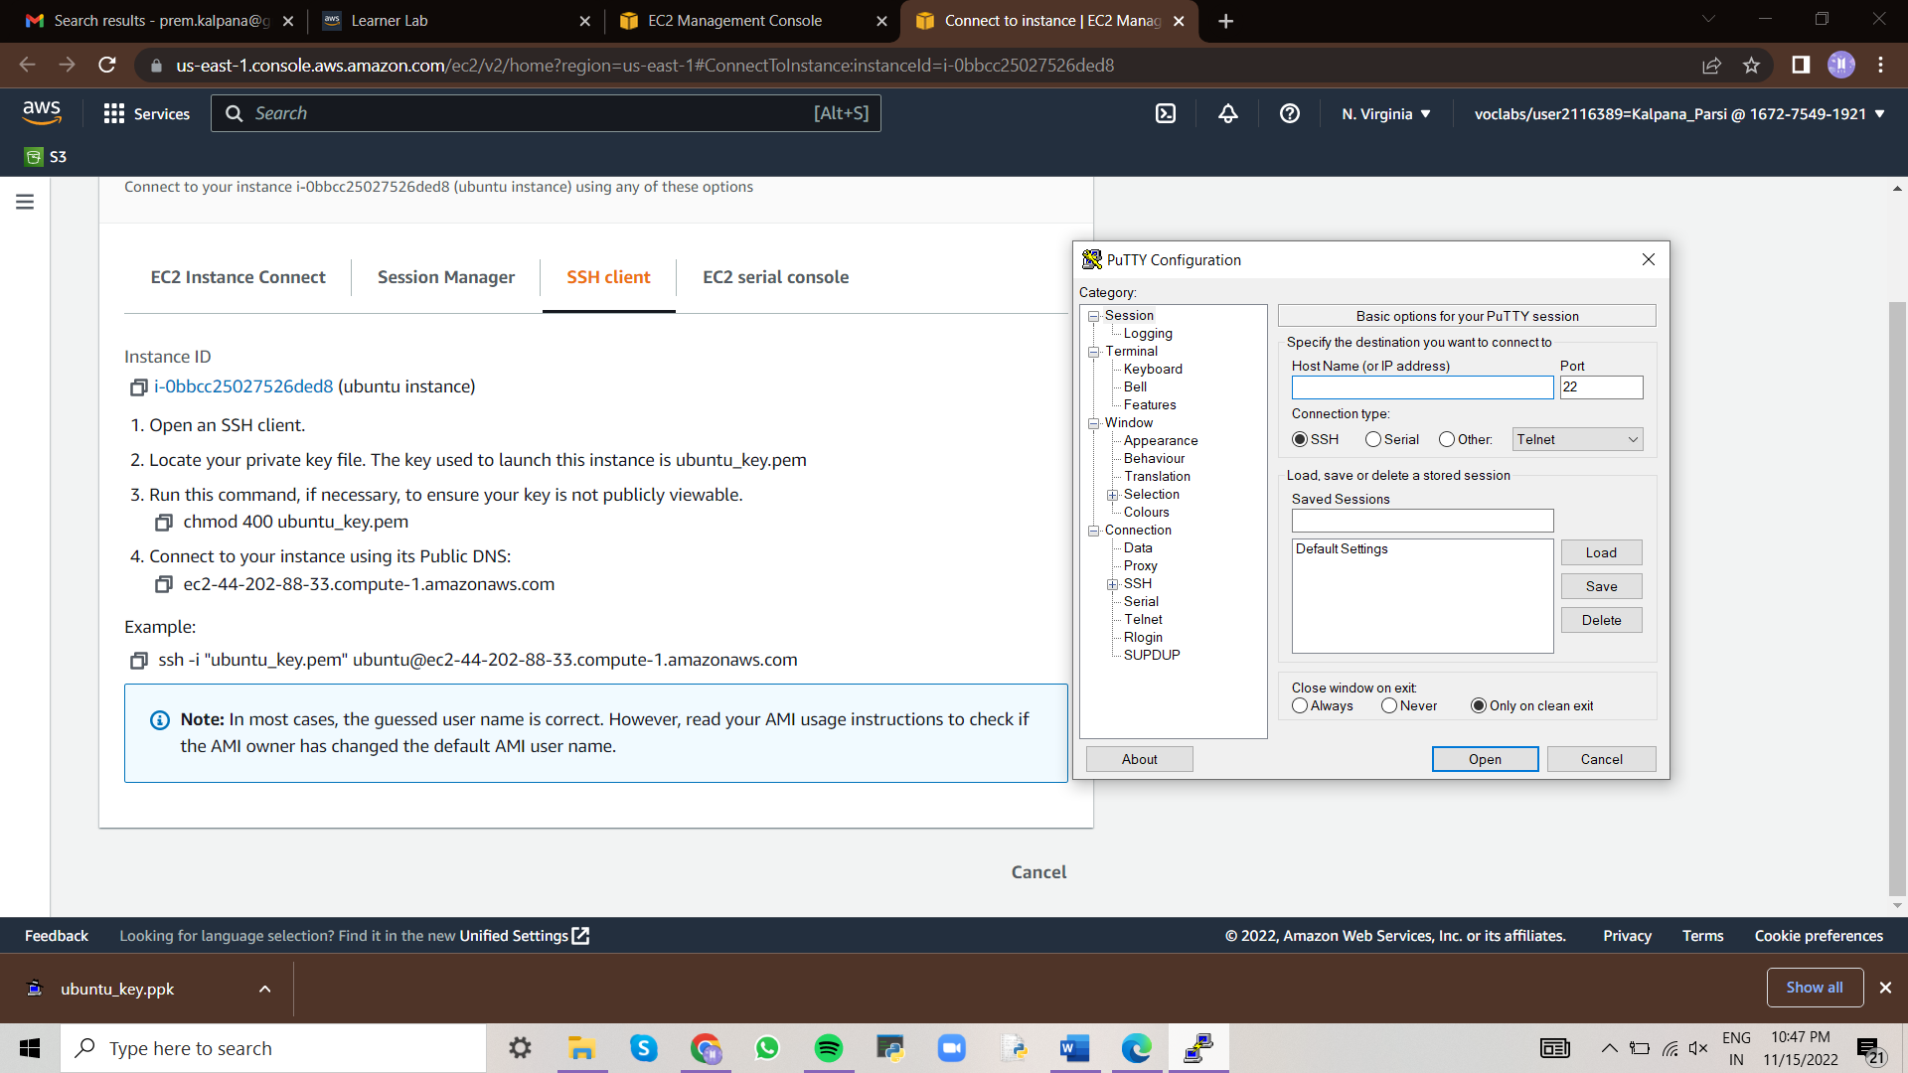

Enter the Public DNS of your Instance in Host Name(IP address)

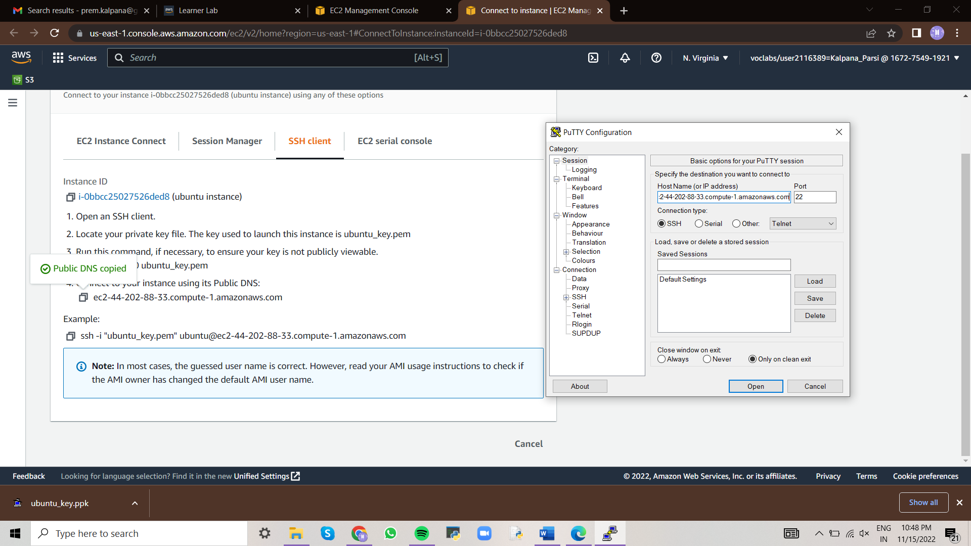

Click on Connection – SSH – Auth – Credentials –

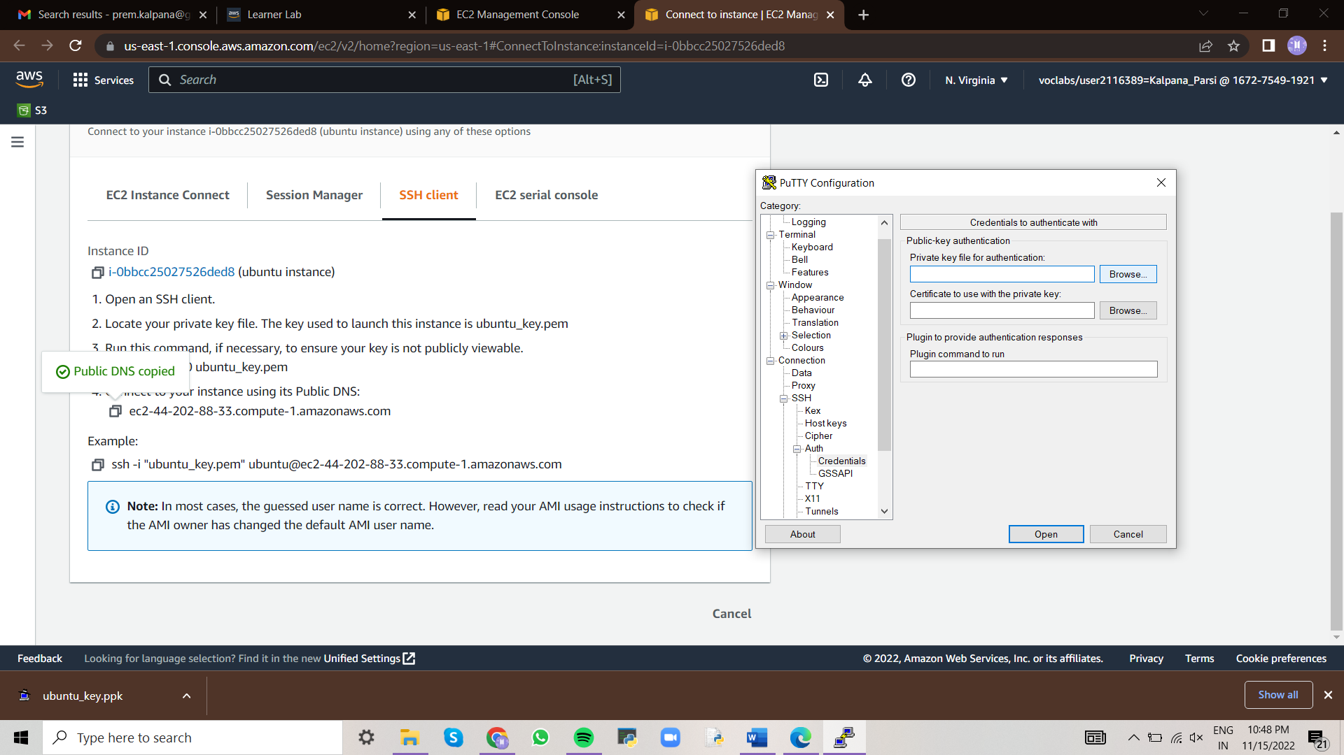

Private key for Authentication - Browse - select the .ppk which was downloaded when EC2 instance is created

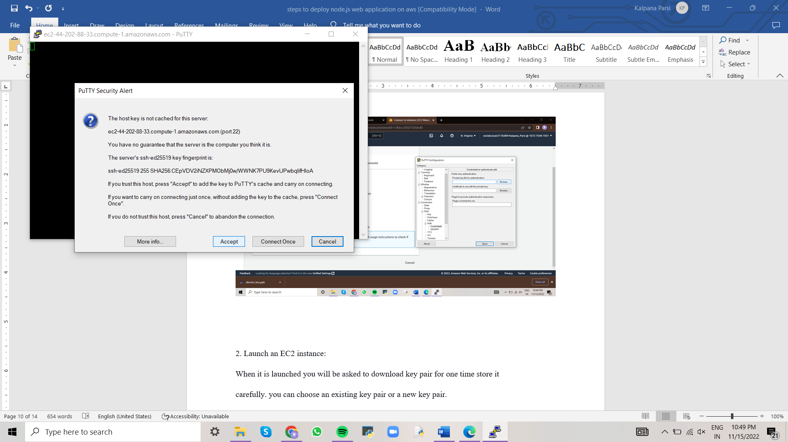

Once entered, it will ask you to confirm, click on Accept

Once it is opened login as ubuntu

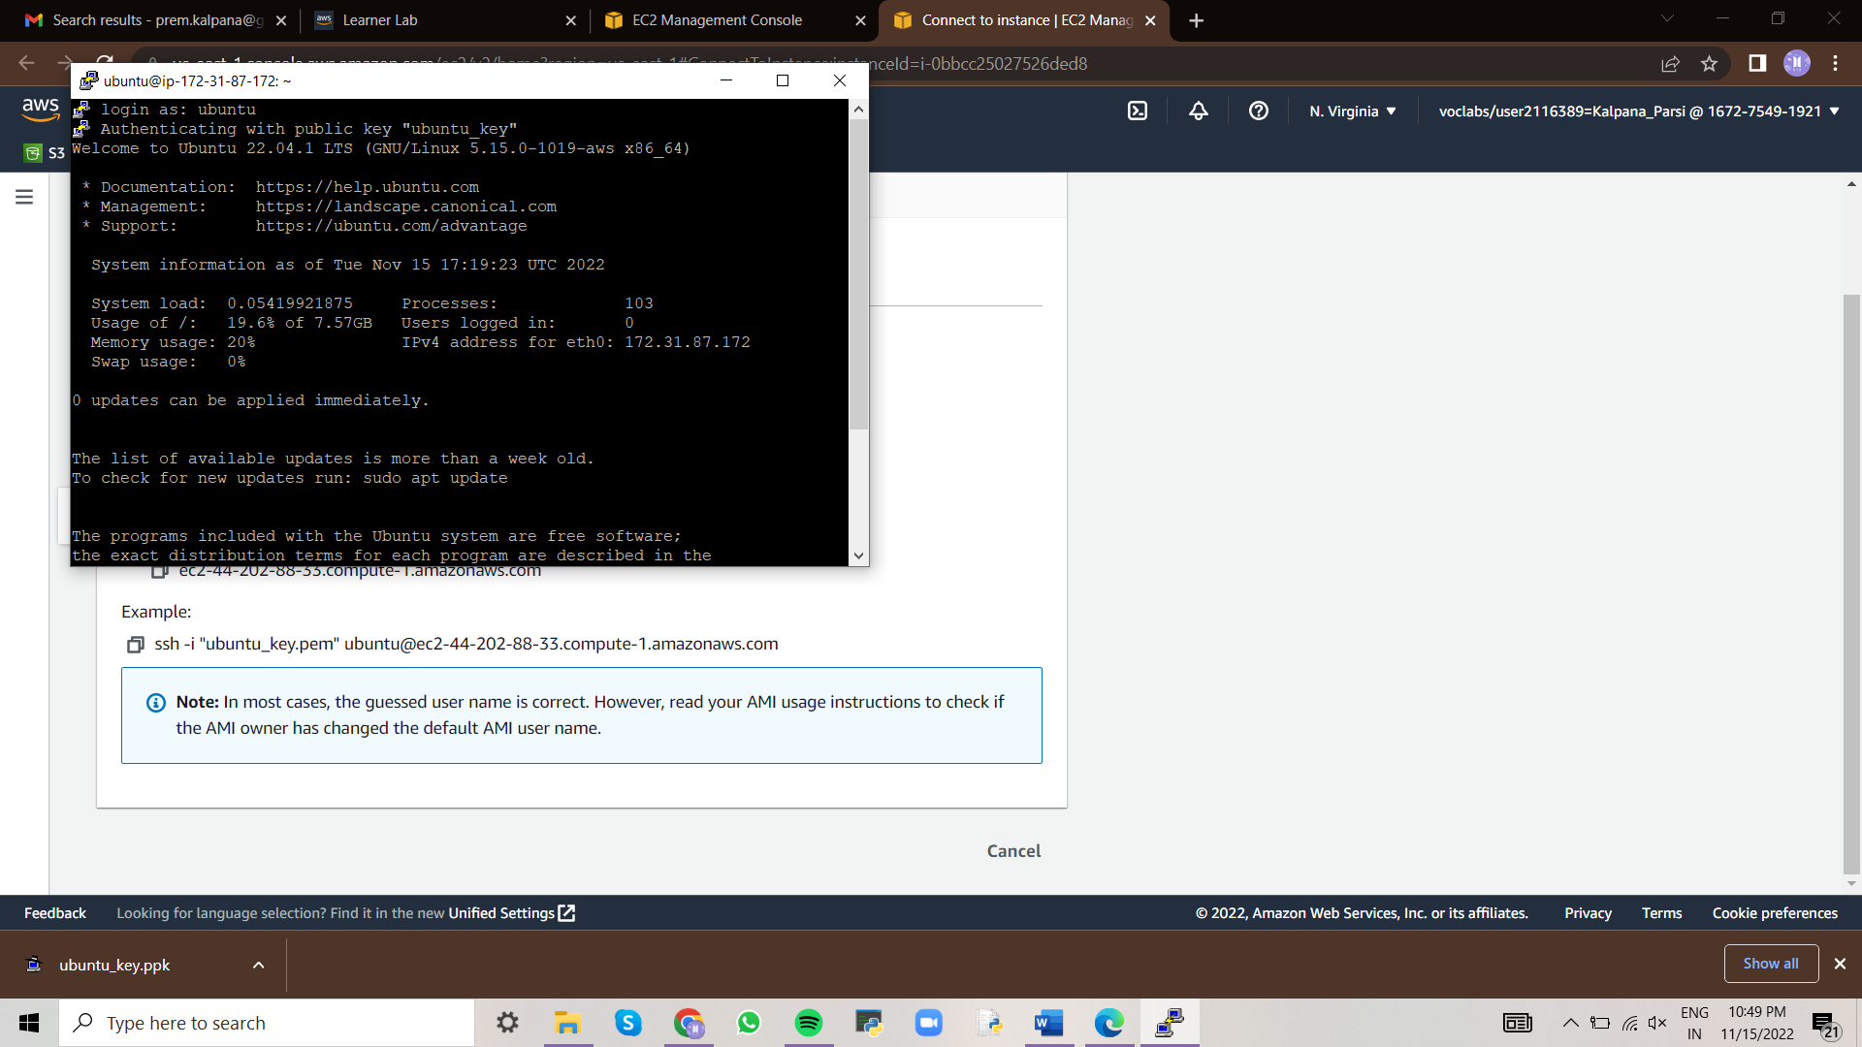

mkdir demo

cd demo

git clone <https://github.com/hoanghuynh1995/AirlineReservation>

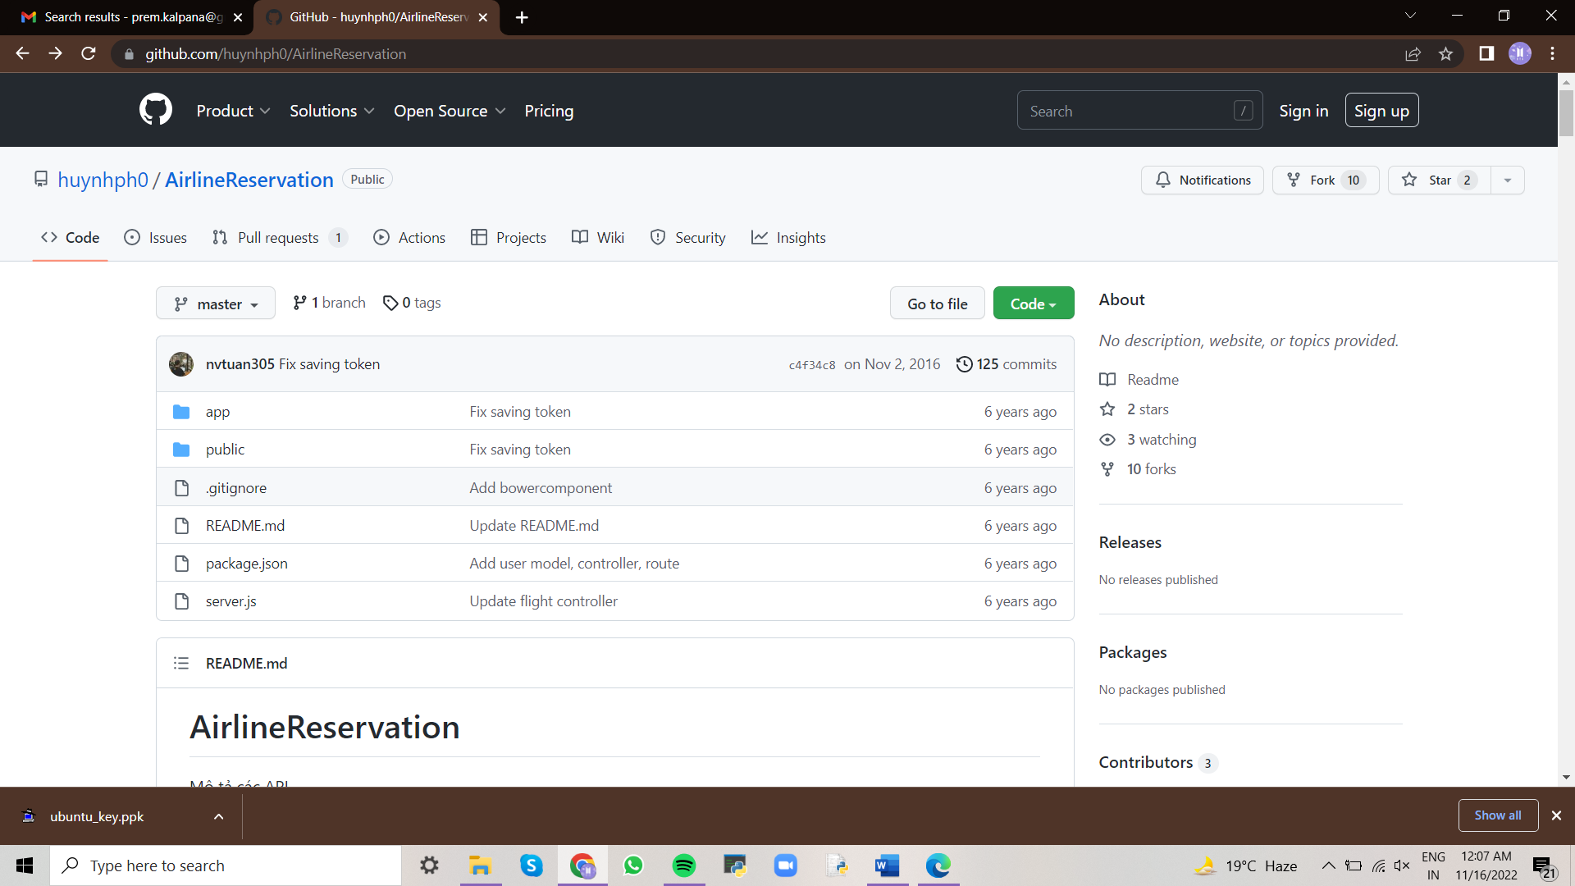

cd AirlineReservation

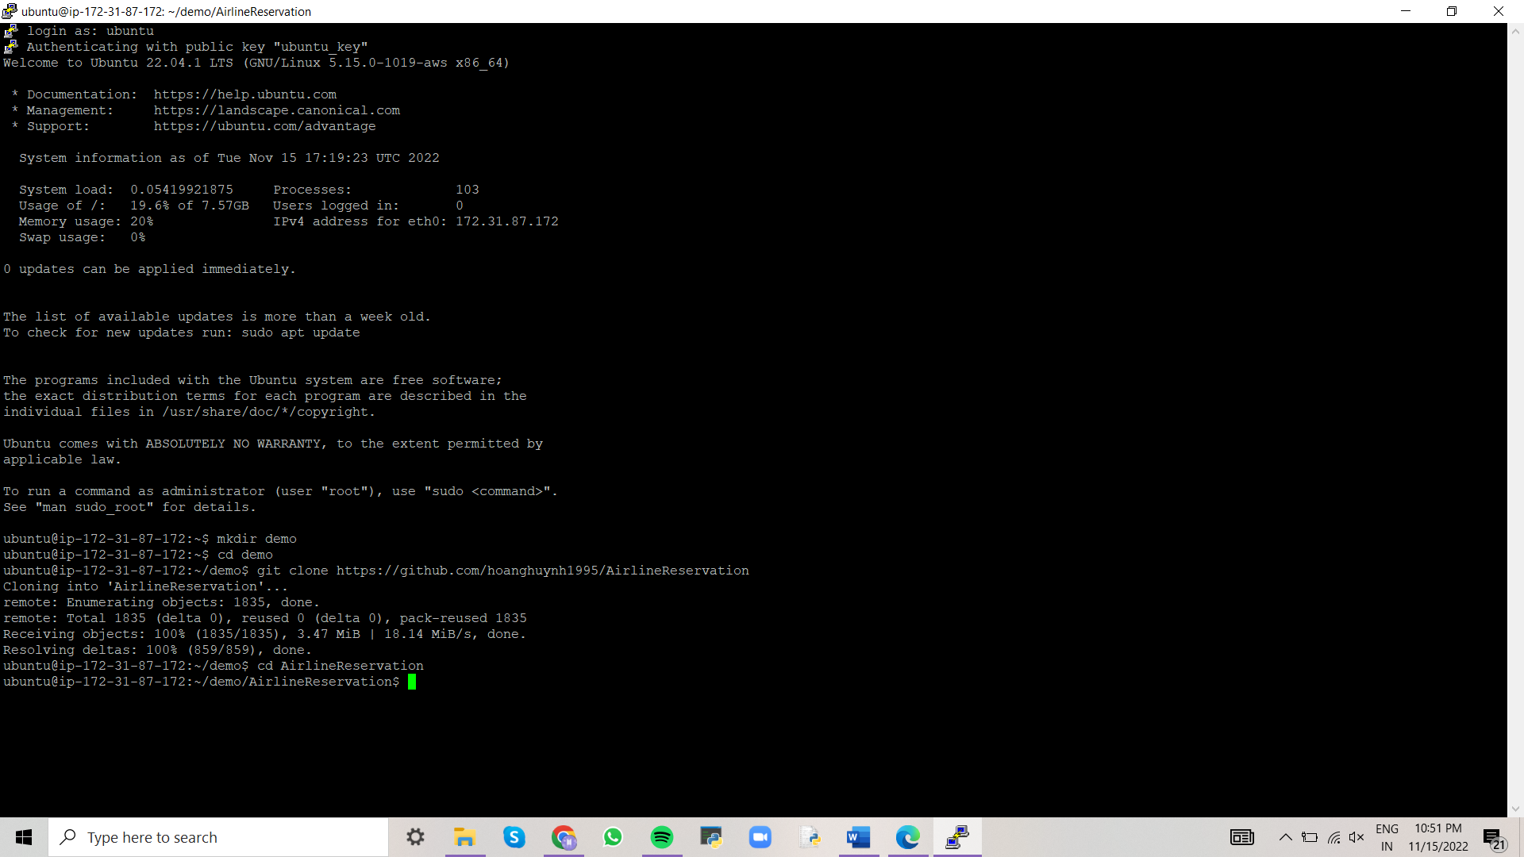

sudo apt-get update //to download package information from all configured sources

sudo apt-get install npm

//to install Node.js on ubuntu, we must first install npm (node package manager)

select Yes

Ok

npm install

sudo apt-get install nodejs //to install Node.js on ubuntu

open server.js file using vi editor and change the port no to 80, and save file and exit

sudo node server.js

Copy public DNS of your instance in new tab and view the deployed web application.

